DEA

Steven Kalinoff

10-30-2022

#install.packages("Benchmarking")  
library(Benchmarking)  
#installl.packages("ucminf")  
library(ucminf)

x = matrix(c(150, 400, 320, 520, 350, 320))  
y = matrix(c(.2, .7, 1.2, 2, 1.2, .7, 14000, 14000, 42000, 28000, 19000, 14000, 3500, 21000, 10500,42000, 25000, 15000),ncol = 3)  
colnames(y) <- c("Supplies","Reimbursed","Paid Patient-Days")  
colnames(x) <- c("Staff Hours Per Day")  
x

## Staff Hours Per Day  
## [1,] 150  
## [2,] 400  
## [3,] 320  
## [4,] 520  
## [5,] 350  
## [6,] 320

y

## Supplies Reimbursed Paid Patient-Days  
## [1,] 0.2 14000 3500  
## [2,] 0.7 14000 21000  
## [3,] 1.2 42000 10500  
## [4,] 2.0 28000 42000  
## [5,] 1.2 19000 25000  
## [6,] 0.7 14000 15000

e <- dea(x,y,RTS = "crs") # provide the input and output   
e

## [1] 0.7111 0.6500 1.0000 1.0000 0.9205 0.6482

peers(e) # identify the peers

## peer1 peer2  
## [1,] 3 NA  
## [2,] 4 NA  
## [3,] 3 NA  
## [4,] 4 NA  
## [5,] 3 4  
## [6,] 3 4

lambda(e) # identify the relative weights given to the peers

## L3 L4  
## [1,] 0.33333333 0.0000000  
## [2,] 0.00000000 0.5000000  
## [3,] 1.00000000 0.0000000  
## [4,] 0.00000000 1.0000000  
## [5,] 0.06666667 0.5785714  
## [6,] 0.11428571 0.3285714

rowSums(x)

## [1] 150 400 320 520 350 320

rowSums(y)

## [1] 17500.2 35000.7 52501.2 70002.0 44001.2 29000.7

dea.plot( rowSums(x),rowSums(y),RTS="crs")

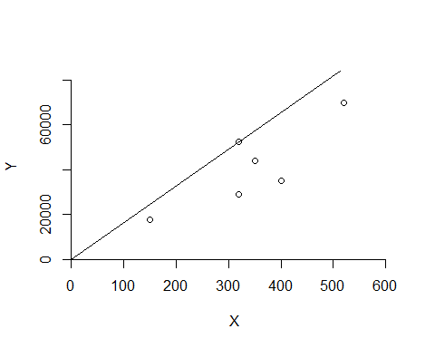

# in the CRS form we can see that sites 1,4 are efficient by checking peers(e); 5 and 6 should both use 3 and 4 for reference

##VRS  
x = matrix(c(150,400,320,520,350,320,.2,.7,1.2,2,1.2,.7),ncol = 2)  
y = matrix(c(14000, 14000, 42000, 28000, 19000, 14000, 3500, 21000, 10500,42000, 25000, 15000),ncol = 2)  
colnames(y) <- c("Reimbursed","Paid Patient-Days")  
colnames(x) <- c("Staff Hours Per Day","Supplies")  
x

## Staff Hours Per Day Supplies  
## [1,] 150 0.2  
## [2,] 400 0.7  
## [3,] 320 1.2  
## [4,] 520 2.0  
## [5,] 350 1.2  
## [6,] 320 0.7

y

## Reimbursed Paid Patient-Days  
## [1,] 14000 3500  
## [2,] 14000 21000  
## [3,] 42000 10500  
## [4,] 28000 42000  
## [5,] 19000 25000  
## [6,] 14000 15000

e <- dea(x,y,RTS = "vrs")   
e

## [1] 1.0000 1.0000 1.0000 1.0000 1.0000 0.8963

peers(e)

## peer1 peer2 peer3  
## [1,] 1 NA NA  
## [2,] 2 NA NA  
## [3,] 3 NA NA  
## [4,] 4 NA NA  
## [5,] 5 NA NA  
## [6,] 1 2 5

lambda(e)

## L1 L2 L3 L4 L5  
## [1,] 1.0000000 0.0000000 0 0 0.0000000  
## [2,] 0.0000000 1.0000000 0 0 0.0000000  
## [3,] 0.0000000 0.0000000 1 0 0.0000000  
## [4,] 0.0000000 0.0000000 0 1 0.0000000  
## [5,] 0.0000000 0.0000000 0 0 1.0000000  
## [6,] 0.4014399 0.3422606 0 0 0.2562995

rowSums(x)

## [1] 150.2 400.7 321.2 522.0 351.2 320.7

rowSums(y)

## [1] 17500 35000 52500 70000 44000 29000

dea.plot( rowSums(x),rowSums(y),RTS="vrs") # plot the results

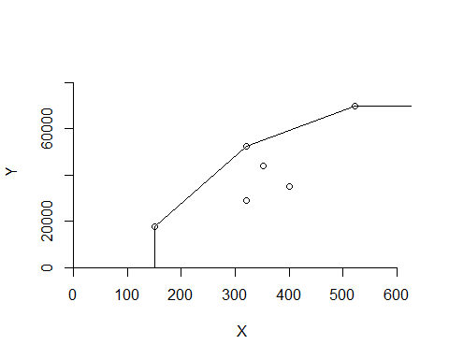

# Using VRS only site 6 is ineffective and should use sites 2 and 5 for the single best reference site 1 has the greatest lambada of .4

##FDH  
x = matrix(c(150,400,320,520,350,320,.2,.7,1.2,2,1.2,.7),ncol = 2)  
y = matrix(c(14000, 14000, 42000, 28000, 19000, 14000, 3500, 21000, 10500,42000, 25000, 15000),ncol = 2)  
colnames(y) <- c("Reimbursed","Paid Patient-Days")  
colnames(x) <- c("Staff Hours Per Day","Supplies")  
x

## Staff Hours Per Day Supplies  
## [1,] 150 0.2  
## [2,] 400 0.7  
## [3,] 320 1.2  
## [4,] 520 2.0  
## [5,] 350 1.2  
## [6,] 320 0.7

y

## Reimbursed Paid Patient-Days  
## [1,] 14000 3500  
## [2,] 14000 21000  
## [3,] 42000 10500  
## [4,] 28000 42000  
## [5,] 19000 25000  
## [6,] 14000 15000

e <- dea(x,y,RTS = "fdh")   
e

## [1] 1 1 1 1 1 1

peers(e)

## peer1  
## [1,] 1  
## [2,] 2  
## [3,] 3  
## [4,] 4  
## [5,] 5  
## [6,] 6

lambda(e)

## L1 L2 L3 L4 L5 L6  
## [1,] 1 0 0 0 0 0  
## [2,] 0 1 0 0 0 0  
## [3,] 0 0 1 0 0 0  
## [4,] 0 0 0 1 0 0  
## [5,] 0 0 0 0 1 0  
## [6,] 0 0 0 0 0 1

rowSums(x)

## [1] 150.2 400.7 321.2 522.0 351.2 320.7

rowSums(y)

## [1] 17500 35000 52500 70000 44000 29000

dea.plot( rowSums(x),rowSums(y),RTS="fdh") # plot the results

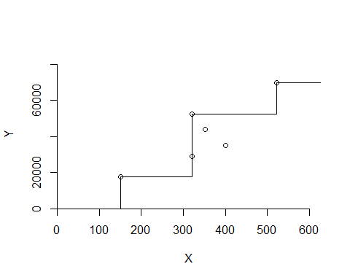

# Under the FDH model all sites are efficient with every sites peer being itself and a perfect lambdas forming a perfect unit matrix

##IRS  
x = matrix(c(150,400,320,520,350,320,.2,.7,1.2,2,1.2,.7),ncol = 2)  
y = matrix(c(14000, 14000, 42000, 28000, 19000, 14000, 3500, 21000, 10500,42000, 25000, 15000),ncol = 2)  
colnames(y) <- c("Reimbursed","Paid Patient-Days")  
colnames(x) <- c("Staff Hours Per Day","Supplies")  
x

## Staff Hours Per Day Supplies  
## [1,] 150 0.2  
## [2,] 400 0.7  
## [3,] 320 1.2  
## [4,] 520 2.0  
## [5,] 350 1.2  
## [6,] 320 0.7

y

## Reimbursed Paid Patient-Days  
## [1,] 14000 3500  
## [2,] 14000 21000  
## [3,] 42000 10500  
## [4,] 28000 42000  
## [5,] 19000 25000  
## [6,] 14000 15000

e <- dea(x,y,RTS = "IRS")   
e

## [1] 1.0000 1.0000 1.0000 1.0000 1.0000 0.8963

peers(e)

## peer1 peer2 peer3  
## [1,] 1 NA NA  
## [2,] 2 NA NA  
## [3,] 3 NA NA  
## [4,] 4 NA NA  
## [5,] 5 NA NA  
## [6,] 1 2 5

lambda(e)

## L1 L2 L3 L4 L5  
## [1,] 1.0000000 0.0000000 0 0 0.0000000  
## [2,] 0.0000000 1.0000000 0 0 0.0000000  
## [3,] 0.0000000 0.0000000 1 0 0.0000000  
## [4,] 0.0000000 0.0000000 0 1 0.0000000  
## [5,] 0.0000000 0.0000000 0 0 1.0000000  
## [6,] 0.4014399 0.3422606 0 0 0.2562995

rowSums(x)

## [1] 150.2 400.7 321.2 522.0 351.2 320.7

rowSums(y)

## [1] 17500 35000 52500 70000 44000 29000

dea.plot( rowSums(x),rowSums(y),RTS="irs") # plot the results

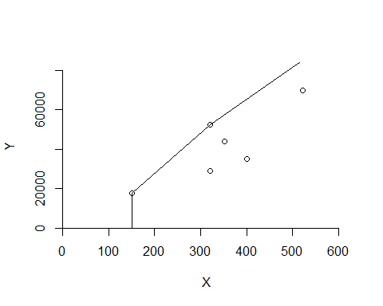

# The IRS model shows that only site 6 is inefficient

##IRS2  
x = matrix(c(150,400,320,520,350,320,.2,.7,1.2,2,1.2,.7),ncol = 2)  
y = matrix(c(14000, 14000, 42000, 28000, 19000, 14000, 3500, 21000, 10500,42000, 25000, 15000),ncol = 2)  
colnames(y) <- c("Reimbursed","Paid Patient-Days")  
colnames(x) <- c("Staff Hours Per Day","Supplies")  
x

## Staff Hours Per Day Supplies  
## [1,] 150 0.2  
## [2,] 400 0.7  
## [3,] 320 1.2  
## [4,] 520 2.0  
## [5,] 350 1.2  
## [6,] 320 0.7

y

## Reimbursed Paid Patient-Days  
## [1,] 14000 3500  
## [2,] 14000 21000  
## [3,] 42000 10500  
## [4,] 28000 42000  
## [5,] 19000 25000  
## [6,] 14000 15000

e <- dea(x,y,RTS = "IRS2")   
e

## [1] 1 1 1 1 1 1

peers(e)

## peer1  
## [1,] 1  
## [2,] 2  
## [3,] 3  
## [4,] 4  
## [5,] 5  
## [6,] 6

lambda(e)

## L1 L2 L3 L4 L5 L6  
## [1,] 1 0 0 0 0 0  
## [2,] 0 1 0 0 0 0  
## [3,] 0 0 1 0 0 0  
## [4,] 0 0 0 1 0 0  
## [5,] 0 0 0 0 1 0  
## [6,] 0 0 0 0 0 1

rowSums(x)

## [1] 150.2 400.7 321.2 522.0 351.2 320.7

rowSums(y)

## [1] 17500 35000 52500 70000 44000 29000

dea.plot( rowSums(x),rowSums(y),RTS="irs2") # plot the results

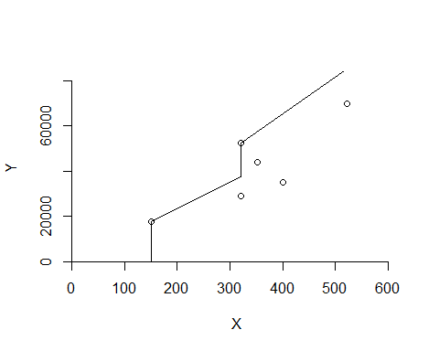

# The IRS2 model all sites to be efficient intrestingly it shows a mix of the stepwise shape of the FDH model and the stepped ramp of the IRS model

##DRS  
x = matrix(c(150,400,320,520,350,320,.2,.7,1.2,2,1.2,.7),ncol = 2)  
y = matrix(c(14000, 14000, 42000, 28000, 19000, 14000, 3500, 21000, 10500,42000, 25000, 15000),ncol = 2)  
colnames(y) <- c("Reimbursed","Paid Patient-Days")  
colnames(x) <- c("Staff Hours Per Day","Supplies")  
x

## Staff Hours Per Day Supplies  
## [1,] 150 0.2  
## [2,] 400 0.7  
## [3,] 320 1.2  
## [4,] 520 2.0  
## [5,] 350 1.2  
## [6,] 320 0.7

y

## Reimbursed Paid Patient-Days  
## [1,] 14000 3500  
## [2,] 14000 21000  
## [3,] 42000 10500  
## [4,] 28000 42000  
## [5,] 19000 25000  
## [6,] 14000 15000

e <- dea(x,y,RTS = "drs")   
e

## [1] 1.0000 1.0000 1.0000 1.0000 0.9775 0.8675

peers(e)

## peer1 peer2 peer3  
## [1,] 1 NA NA  
## [2,] 2 NA NA  
## [3,] 3 NA NA  
## [4,] 4 NA NA  
## [5,] 1 2 4  
## [6,] 1 2 4

lambda(e)

## L1 L2 L3 L4  
## [1,] 1.0000000 0.00000000 0 0.0000000  
## [2,] 0.0000000 1.00000000 0 0.0000000  
## [3,] 0.0000000 0.00000000 1 0.0000000  
## [4,] 0.0000000 0.00000000 0 1.0000000  
## [5,] 0.2000000 0.08048142 0 0.5383307  
## [6,] 0.3428571 0.39499264 0 0.1310751

rowSums(x)

## [1] 150.2 400.7 321.2 522.0 351.2 320.7

rowSums(y)

## [1] 17500 35000 52500 70000 44000 29000

dea.plot( rowSums(x),rowSums(y),RTS="drs") # plot the results

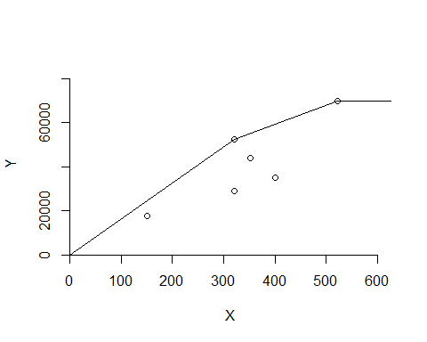

# The DRS model shows site 5 and 6 to be inefficient with lambdas only as high as ~.54 site 5 can be corrected by modeling site 4 and 6 by either sites 1 or 2 with 2 being likely yielding a higher match.

##FRH  
x = matrix(c(150,400,320,520,350,320,.2,.7,1.2,2,1.2,.7),ncol = 2)  
y = matrix(c(14000, 14000, 42000, 28000, 19000, 14000, 3500, 21000, 10500,42000, 25000, 15000),ncol = 2)  
colnames(y) <- c("Reimbursed","Paid Patient-Days")  
colnames(x) <- c("Staff Hours Per Day","Supplies")  
x

## Staff Hours Per Day Supplies  
## [1,] 150 0.2  
## [2,] 400 0.7  
## [3,] 320 1.2  
## [4,] 520 2.0  
## [5,] 350 1.2  
## [6,] 320 0.7

y

## Reimbursed Paid Patient-Days  
## [1,] 14000 3500  
## [2,] 14000 21000  
## [3,] 42000 10500  
## [4,] 28000 42000  
## [5,] 19000 25000  
## [6,] 14000 15000

e <- dea(x,y,RTS = "add")   
e

## [1] 1 1 1 1 1 1

peers(e)

## peer1  
## [1,] 1  
## [2,] 2  
## [3,] 3  
## [4,] 4  
## [5,] 5  
## [6,] 6

lambda(e)

## L1 L2 L3 L4 L5 L6  
## [1,] 1 0 0 0 0 0  
## [2,] 0 1 0 0 0 0  
## [3,] 0 0 1 0 0 0  
## [4,] 0 0 0 1 0 0  
## [5,] 0 0 0 0 1 0  
## [6,] 0 0 0 0 0 1

rowSums(x)

## [1] 150.2 400.7 321.2 522.0 351.2 320.7

rowSums(y)

## [1] 17500 35000 52500 70000 44000 29000

dea.plot( rowSums(x),rowSums(y),RTS="add") # plot the results

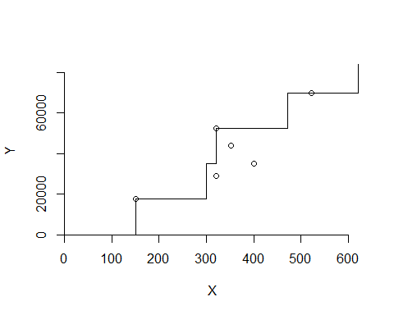

# The FRH model shows all sites to be efficient

# I think that for this given set of data that the CRS assumptions give the most contrast to the potiental ineffective sites and that they show that the best lambda corrections >50% can be applied to model the other sites.